Greece
The cradle of philosophy, democracy, the arts, and science. In Greece, there has always been trade amongst people from all around the World. That’s how people could meet, talk about their cultures, and learn from one another.

- What is the capital of Greece?

Planning a holiday trip

- Greece consists of many small islands. Try to find the individual islands on a map.

……………..
………..
……………..
……………
…………..
…………….
………….

- Choose an Island and plan a holiday trip for your whole family. We are looking for interesting places for each member of the family. You can use catalogs from travel agencies for example. Focus on:
- Historical monuments
- Natural reservations
- Food
- Music and art
- The sea and beaches
- Sports activities

- Greece belongs to the group of so-called collectivistic countries. We further distinguish individualistic countries. Explain in your own words the difference between the two terms.

- Collectivistic countries-

- Individualistic countries-

- Is the Czech Republic a collectivistic country or and individualistic country?

- Try to write down 3 examples why.

Greek belongs to the Indo-European language family. The Greek alphabet is called the alfabet.
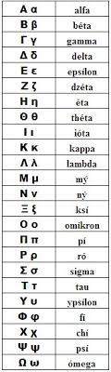

- Write down your first name using the Greek alfabet.

………………………………………………………………………………….

- Color in the Greek flag.
